Session 5 - 1

import java.lang.reflect.Method;

class Printer {
public <T> void printArray(T[] array) {
for (T element : array) {
System.out.println(element);
}
}
}

public class Solution {
public static void main(String args[]) {
Printer myPrinter = new Printer();
Integer[] intArray = { 1, 2, 3 };
String[] stringArray = {"Hello", "World"};
myPrinter.printArray(intArray);
myPrinter.printArray(stringArray);
int count = 0;

for (Method method : Printer.class.getDeclaredMethods()) {
String name = method.getName();

if(name.equals("printArray"))
count++;
}

if(count > 1) System.out.println("Method overloading is not allowed!");
}
}
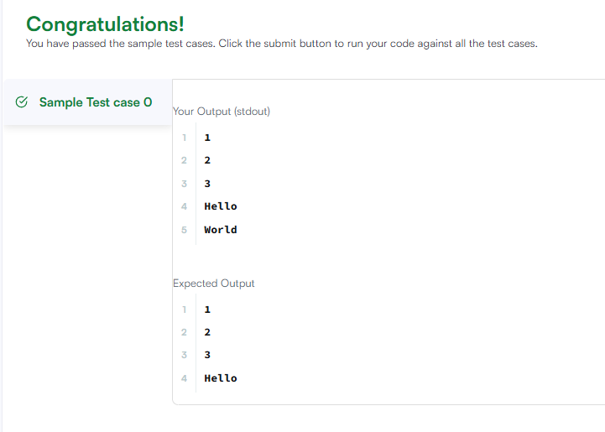

Session 5 - 2

import java.util.ArrayList;
import java.util.HashMap;
import java.util.HashSet;
import java.util.List;
import java.util.Map;
import java.util.Set;

class ThroneInheritance {
private String king;
private Map<String, List<String>> familyTree;
private Set<String> deadPeople;

public ThroneInheritance(String kingName) {
this.king = kingName;
this.familyTree = new HashMap<>();
this.deadPeople = new HashSet<>();
this.familyTree.put(kingName, new ArrayList<>());
}

public void birth(String parentName, String childName) {
this.familyTree.putIfAbsent(parentName, new ArrayList<>());
this.familyTree.get(parentName).add(childName);
}

public void death(String name) {
this.deadPeople.add(name);
}

public List<String> getInheritanceOrder() {
List<String> order = new ArrayList<>();
dfs(king, order);
return order;
}

private void dfs(String current, List<String> order) {
if (!deadPeople.contains(current)) {
order.add(current);
}
List<String> children = familyTree.get(current);
if (children != null) {
for (String child : children) {
dfs(child, order);
}
}
}
}

